DBS HW 5

Group: Helen Kim, Dominic Lee

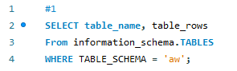

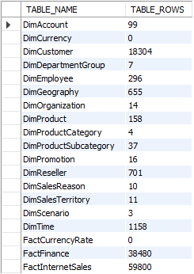

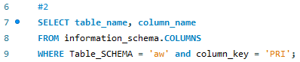

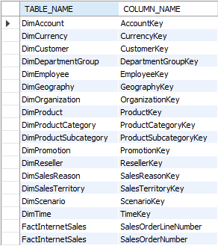

1. Dimension tables all start with “Dim” and fact tables all start with “Fact”.
2. DimEmployee is recursive because one of the table values are supervisor’s of the employee (those who are above certain workers in the company but still considered an employee, they just have a higher ranking)
3. The three types of models of bikes are Road, Mountain, and Touring.
4. The type of bike model that had the highest sales (in dollar volume) in 2004 was Mountain.

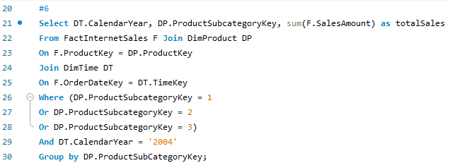

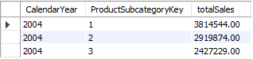

1. Seats

Tires

Jerseys/Shorts-sleeve

Hydration Pack

Patch Kit

1. The most popular color of bikes sold in each of the 4 years were:

2001: Red

2002: Red

2003: Black

2004: Black

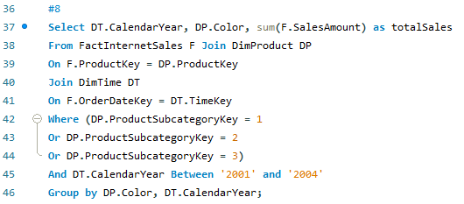

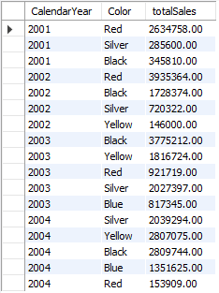

1. June, 2004

| Gender | CalendarYear | MonthNumberOfYear | TotalSales |
| --- | --- | --- | --- |
| F | 2002 | 11 | 169329 |
| F | 2003 | 1 | 198629 |
| F | 2002 | 9 | 200786 |
| F | 2002 | 10 | 215702 |
| F | 2001 | 7 | 220013 |
| F | 2003 | 3 | 224635 |
| F | 2001 | 9 | 225433 |
| F | 2001 | 10 | 227888 |
| F | 2003 | 4 | 240094 |
| F | 2002 | 7 | 249789 |
| F | 2003 | 2 | 259179 |
| F | 2003 | 5 | 263740 |
| F | 2001 | 11 | 266642 |
| F | 2002 | 2 | 270474 |
| F | 2002 | 8 | 294438 |
| F | 2001 | 8 | 295145 |
| F | 2002 | 12 | 297786 |
| F | 2003 | 6 | 301218 |
| F | 2002 | 3 | 306433 |
| F | 2002 | 1 | 315140 |
| F | 2002 | 6 | 335380 |
| F | 2002 | 4 | 352694 |
| F | 2002 | 5 | 367802 |
| F | 2001 | 12 | 375485 |
| F | 2003 | 8 | 383922 |
| F | 2003 | 7 | 443430 |
| F | 2003 | 9 | 454582 |
| F | 2003 | 10 | 547022 |
| F | 2003 | 11 | 582473 |
| F | 2004 | 1 | 643198 |
| F | 2004 | 2 | 673708 |
| F | 2004 | 3 | 687611 |
| F | 2004 | 4 | 781593 |
| F | 2003 | 12 | 818534 |
| F | 2004 | 5 | 892596 |
| F | 2004 | 6 | 913734 |



SQL Scripts:

#1

SELECT table_name, table_rows

From information_schema.TABLES

WHERE TABLE_SCHEMA = 'aw';

#2

SELECT table_name, column_name

FROM information_schema.COLUMNS

WHERE Table_SCHEMA = 'aw' and column_key = 'PRI';

#3

-- USE aw;

SELECT *

From FactInternetSales join DimProduct;

#5

SELECT *

From FactInternetSales join DimProduct;

#6

Select DT.CalendarYear, DP.ProductSubcategoryKey, sum(F.SalesAmount) as totalSales

From FactInternetSales F Join DimProduct DP

On F.ProductKey = DP.ProductKey

Join DimTime DT

On F.OrderDateKey = DT.TimeKey

Where (DP.ProductSubcategoryKey = 1

Or DP.ProductSubcategoryKey = 2

Or DP.ProductSubcategoryKey = 3)

And DT.CalendarYear = '2004'

Group by DP.ProductSubCategoryKey;

#7

SELECT *

From FactInternetSales join DimProduct;

#8

Select DT.CalendarYear, DP.Color, sum(F.SalesAmount) as totalSales

From FactInternetSales F Join DimProduct DP

On F.ProductKey = DP.ProductKey

Join DimTime DT

On F.OrderDateKey = DT.TimeKey

Where (DP.ProductSubcategoryKey = 1

Or DP.ProductSubcategoryKey = 2

Or DP.ProductSubcategoryKey = 3)

And DT.CalendarYear Between '2001' and '2004'

Group by DP.Color, DT.CalendarYear;

#9

use aw;

select C.Gender, T.CalendarYear, T.MonthNumberOfYear, sum(S.UnitPrice)

TotalSales from FactInternetSales S

join DimProduct P join DimTime T join DimCustomer C on

S.ProductKey = P.ProductKey and S.OrderDateKey = T.TimeKey and

S.CustomerKey = C.CustomerKey

where (P.ProductSubcategoryKey = 1 OR P.ProductSubcategoryKey = 2 or P.ProductSubcategoryKey = 3 and C.gender = 'F')

group by C.Gender, T.CalendarYear, T.MonthNumberOfYear

order by TotalSales;

#10

use aw;

select StateProvinceName as State, sum(UnitPrice-ProductStandardCost) as Profit_Margin, CalendarYear as Year from DimProduct Product

join DimTime T join FactInternetSales Sales join DimCustomer Customer join DimGeography Geo join DimProductSubcategory sub

on Sales.ProductKey = Product.ProductKey

and Sales.OrderDateKey = T.TimeKey and Customer.CustomerKey = Sales.CustomerKey

and Customer.GeographyKey = Geo.GeographyKey

and Product.ProductSubcategoryKey = sub.ProductSubcategoryKey

and CalendarYear = 2003

where EnglishProductSubcategoryName like '%bikes'

GROUP BY State, Year

ORDER BY Profit_Margin DESC

LIMIT 1;